

VERTICAL DIFFUSION PM PROCEDURE (Poly)
PM Type: SPM – Small PM Prepared by:
Machine: LP-Poly Robin 羅彬森
PM Frequency: 9μ±1小PM S200 FURNACE
Date: March 2017

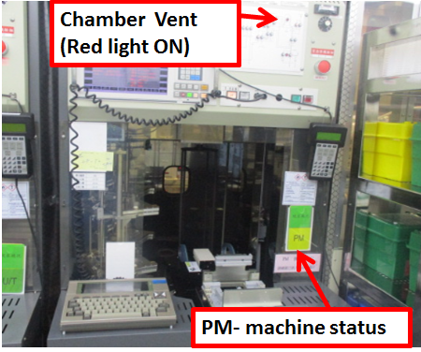 |  | 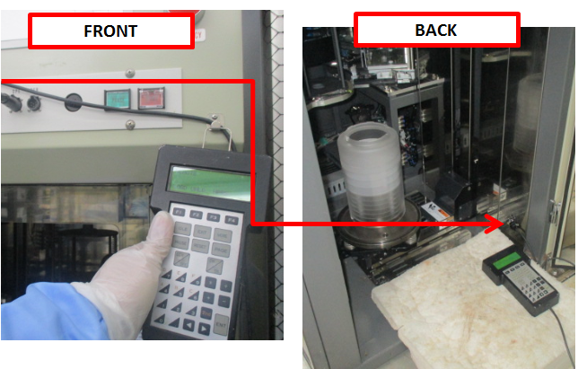 |  | 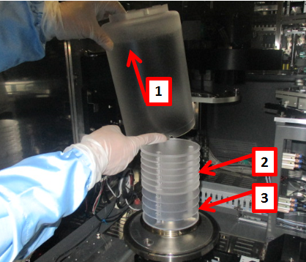
1. Confirm if machine ready for PM, check if machine already vent |  | 2. Get controller from front of machine, and connect to back terminal on lower right side. |  | 3. Remove pedestal cover +7fins+5fins and bring to parts cleaning area

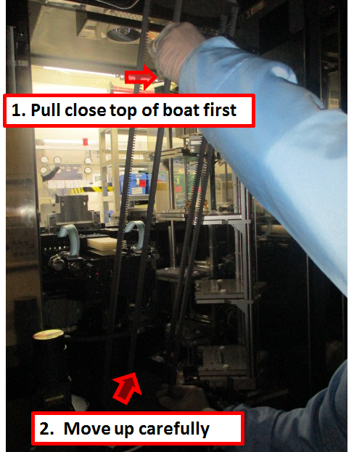 |  | 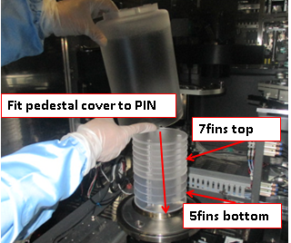 |  | 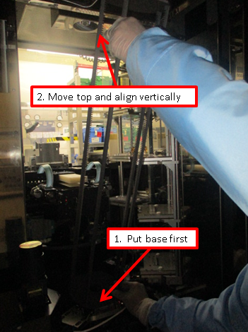
5. Remove boat |  | 5. Install pedestal |  | 6. Install boat

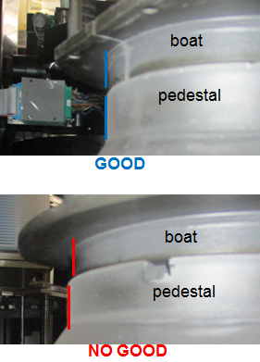 |  | 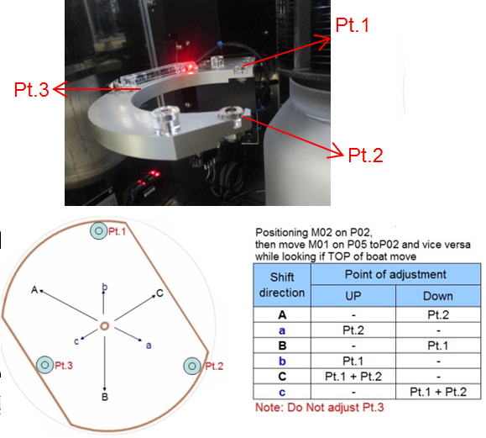 |  | 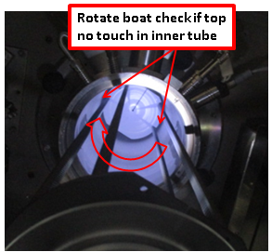
7. Put M06 in P01, put boat on top of pedestal and check alignment |  | 8. while M02 is in P02, Move M01 between P02 and P05, adjust if top of boat move |  | 9. Check chamber and boat gap, move boat at Ht.=1000 and rotate360deg

Doc. #: 2017-CRP-001 rev.00 Page 1 of 2

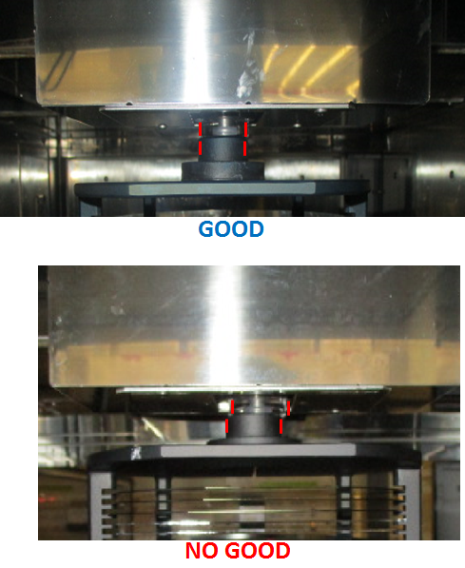 |  | 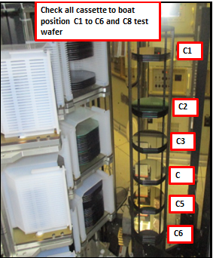 |  | 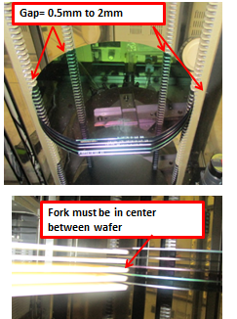
10. Put M02 in P01 to check/adjust boat lock |  | 11. Put boat M02 in P01 to do Transfer check. Load dummy wafer |  | 12. Check/adjust wafer position on boat, and fork gap between wafers

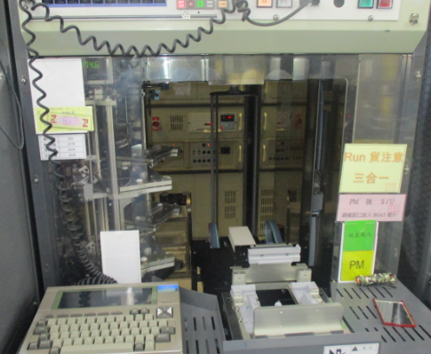 |  | 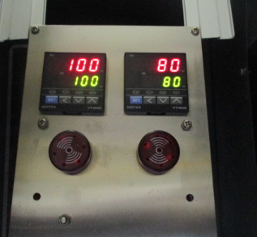 |  | 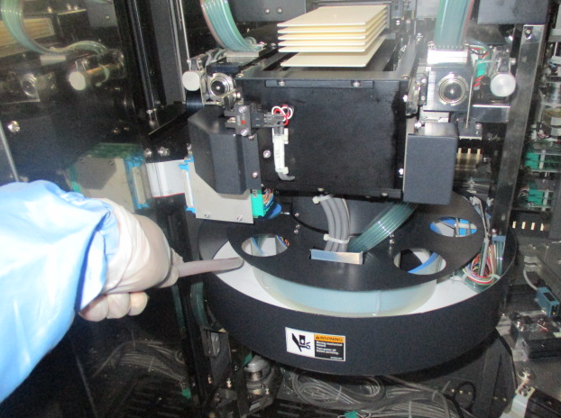
13. Unload dummy wafer and cassette, move boat inside chamber |  | 14. Check and adjust heater temperature settings at back of machine. |  | 15. Clean and Vacuum inside machine and Transfer robot area before close machine

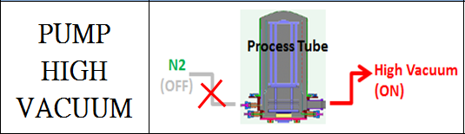 |  | 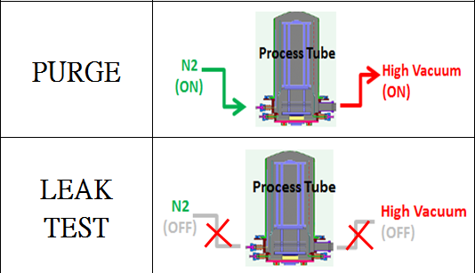 |  | 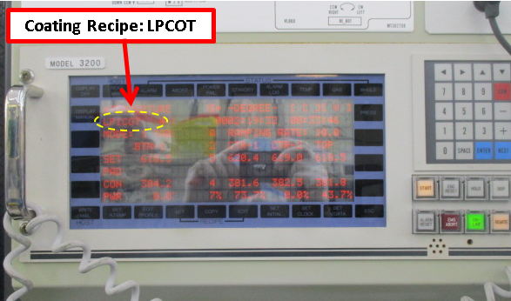
16. close chamber and Pump High vacuum |  | 17. Open heater and purge 30mins, then leak test at High temperature. Pressure must be <0.2 Torr in 130secs. |  | 18. input coating recipe for poly machine

EA TEST RUN
19. fill up machine log book PM OK and endorse to EA for test run

Doc. #: 2017-CRP-001 rev.00 Page 2 of 2

